*This mod must be used with the TerraFirmaCraft mod for Minecraft.*

## Introduction

The idea behind this mod came from a suggestion made by a forum member named Djakuta. His suggestion was to create a Grass Mat to dry fruit.

Forum post - http://terrafirmacraft.com/f/topic/8266-grass-mat-dry-fruit/

This is the initial forum post -

*This is just an idea for an addon. Is made in the hopes that someone with coding skills like it and make it real.*

*The main concept is to be able to use a grass mat to create sun dried fruits.*

*Humankind has been drying fruits since stone age. It was a simple way to preserve food for the long winters and also mixed with other ingredients a way to pack food for traveling.*

*There are several ways that we could achieve this in the game.*

*The Grass Mat can be made with:*

* *Regular grass*
* *Cat Tails*
* *Sea grass*
* *Rattan from a Palm Tree (Not yet in tfc)*

*Weaving the mat:*

* *Created in the Crafting Grid*
* *Using a mini game interface, similar the one in the weaving wool.*

*The Dry Fruit:*

* *raisins and other dry fruits stay edible for a long time.*

*Mechanics:*

* *Just spread the fruits on top of the grass mat up to 160 oz of any fruit per square mat.*
* *How long does it take for the fruit to dry? I think the best is to have a config option, it could be a minimum of 24 hours or even several 15 days.*

*Weather effects:*

* *If is raining fruits will not dry and if left under rain will actually spoil faster.*
* *Fruits need to be covered with another grass mat in case of rain, this stops the drying process and if left fruits will spoil.*

## Items

1. Drying Mat – a mat that is used to dry food items.

## Recipes

### Drying Mat

The drying mats are made using one thatch block and a knife, in the crafting space. You get two drying mats per thatch block.

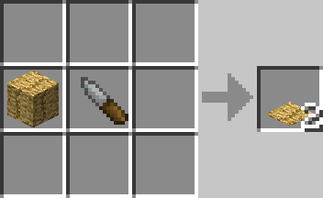

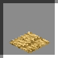

## Process

Before the process can be started, the right conditions must be met. As this is a drying mat, it uses the sun and the temperature to determine if the drying process can start.

The drying mat must adhere to these conditions in order for the process to start:

1. It must be daylight (between 6am and 6pm).
2. It must have clear access to the sky (nothing must cover it). You can cover it with glass or other transparent blocks as this does not prevent access to the sky.
3. The current temperature must be above the temperature in the config file (default 20).

If all these conditions are met, then the drying process can start.

### Starting the Process

If all the conditions above are met, then when an item is added to the drying mat, the process will start. While the process is running, particle clouds will appear from the mat (as seen in the image).

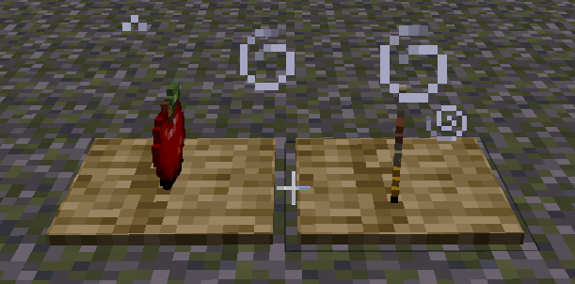

If any of the drying conditions change (eg. it turns to night) the process will stop.

When the player right-clicks the drying mat, the Gui is opened. If the player right-clicks with an empty hand and while sneaking, the player will grab the item on the mat, without the need to open the Gui.

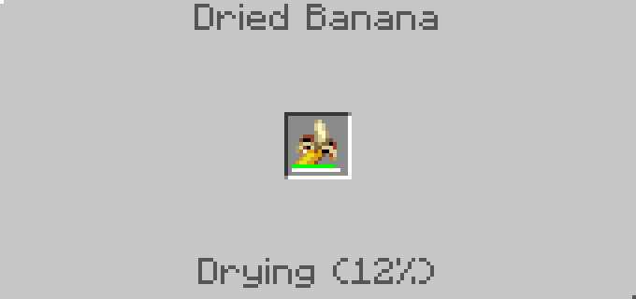

This image shows the drying mat while drying a banana.



This image shows the drying mat after the banana has been dried. The quantity has been reduced.

## Additional Information

1. Currently only fruits and vegetables can be used with the drying mat.
2. While the fruit/vegetable is drying, the decay rate is set to 3/4.
3. If it rains on the drying mat, any fruit will decay at 3 times the rate (spoils quicker), this also includes dried fruits/vegetables.
4. The drying time is determined by the amount of food, smaller food item takes less time to dry.
5. Once the fruit has completed drying, the quantity is halved and the taste profile is doubled.
6. Dried fruits/vegetables look the same as the normal fruits/vegetables, just adds 'Dried' to the start of the name.
7. Drying mats can be stored in chests.
8. Drying mats are stackable.
9. When the player harvests the drying mat from the ground, the item is spawned into the world.
10. If the player right-clicks the mat while sneaking, the item is transferred into the players hand. Your hand must be empty.
11. Config options have been included so that the player can alter certain aspects of the process. The options are:
    1. dryingDelay - Sets the value to the number of ticks between each drying process attempt.
    2. dryingTemperature - Set this value to the temperature in which items exposed to the sun start drying.
12. If you put an item onto the drying mat that does not have a recipe, nothing will happen.

The drying mat uses recipes to dry items. A DryingMatManager was created to store the recipes used by the drying mat. This allows the mat’s functionality to be extended in the future, if needed.

Multiple recipes cannot be created that use the same item. Only one recipe per item.